Project Report Format

# INTRODUCTION

* 1. Project Overview
  2. Purpose

# LITERATURE SURVEY

* 1. Existing problem
  2. References
  3. Problem Statement Definition

# IDEATION & PROPOSED SOLUTION

* 1. Empathy Map Canvas
  2. Ideation & Brainstorming

# REQUIREMENT ANALYSIS

* 1. Functional requirement
  2. Non-Functional requirements

# PROJECT DESIGN

* 1. Data Flow Diagrams & User Stories
  2. Solution Architecture

# PROJECT PLANNING & SCHEDULING

* 1. Technical Architecture
  2. Sprint Planning & Estimation
  3. Sprint Delivery Schedule

# CODING & SOLUTIONING (Explain the features added in the project along with code)

* 1. Feature 1
  2. Feature 2
  3. Database Schema (if Applicable)

# PERFORMANCE TESTING

* 1. Performace Metrics

# RESULTS

* 1. Output Screenshots

1. **ADVANTAGES & DISADVANTAGES**
2. **CONCLUSION**
3. **FUTURE SCOPE**
4. **APPENDIX**

Source Code

GitHub & Project Demo Link

**Unearthing Trends From LinkedIn Influencers**

1. **INTRODUCTION :**

Unearthing trends from LinkedIn influencers is not only about passive observation

but active participation in the discourse of the day. It's a journey of discovery, learning, and collaboration that can yield actionable intelligence. By the end of this report, you will be equipped with the tools and knowledge to harness the power of LinkedIn influencers and leverage their insights to inform your decisions, advance your career, and navigate the evolving landscapes of your industry.

**1.1 Project Overview :**

The objective of this project is to systematically identify, analyze, and report on emerging trends within a specific professional domain by monitoring and engaging with LinkedIn influencers. By doing so, we aim to provide valuable insights that can inform strategic decisions, industry knowledge, and professional growth.

**1.2 Purpose :**

LinkedIn influencers serve several important purposes within the professional

networking platform. These individuals are typically experts, thought leaders, or industry pioneers who use their profiles and content to share insights, knowledge, and expertise. The purposes of LinkedIn influencers include

1. Knowledge Sharing
2. Thought Leadership
3. Professional Development
4. Networking
5. Brand Building.

# 2. LITERATURE SURVEY

# A literature survey on "Unearthing Trends From LinkedIn Influencers" involves

# researching and summarizing existing academic or professional publications, reports,

# and articles related to the topic. Here's a brief overview of what a literature survey on

# this topic might encompass:

# 1. Influence of LinkedIn on Professional Networking

# 2. LinkedIn as a Source of Industry Trends

# 3. Characteristics of LinkedIn Influencers

# 4. LinkedIn and Professional Development

# 5. Ethical Considerations in Influencer Research

**2.1 Existing problem :**

# An existing problem for LinkedIn influencers is the increasing challenge of maintaining authentic engagement and trust among their followers, given the proliferation of sponsored content and the potential for inauthentic collaborations.

**2.2 References :**

LinkedIn influencers are individuals who have established themselves as thought leaders and industry experts on the LinkedIn platform. They regularly share valuable content, insights, and knowledge with their followers, positioning themselves as authorities in their respective fields. These influencers often have a large and engaged following, allowing them to reach a broad professional audience. By doing so, they play a pivotal role in shaping conversations, disseminating trends, and providing guidance to professionals. LinkedIn influencers are often recognized for their expertise, providing a valuable resource for those seeking career advice, industry insights, or professional development. Their influence extends beyond the platform, impacting decision-making and networking in the professional world.

**2.3 Problem Statement Definition :**

A problem statement is a clear and concise description of the issue or challenge that needs to be addressed. It should define the problem in a way that is understandable to stakeholders and provide a basis for developing a solution or course of action.

# 3. IDEATION & PROPOSED SOLUTION :

# Ideation:

# To address the content saturation issue among LinkedIn influencers, the proposed

# solution involves creating a verified "Expertise Badge" system. Influencers would need

# to demonstrate their knowledge and expertise in a specific domain, and upon successful

# verification, they would receive a badge. This badge not only distinguishes genuine

# experts but also guides followers to reliable sources of information, mitigating content

# saturation.

# Solution:

# The "Expertise Badge" system will enhance the credibility of LinkedIn influencers,

# making it easier for users to identify authoritative voices amid the noise, ultimately

# improving the platform's utility and trustworthiness.

**3.1 Empathy Map Canvas :**

An empathy map is a simple, easy-to-digest visual that captures knowledge about a user’s behaviours and attitudes. It is a useful tool to helps teams better understand their users. Creating an effective solution requires understanding the true problem and the person who is experiencing it. The exercise of creating the map helps participants consider things from the user’s perspective along with his or her goals and challenges.

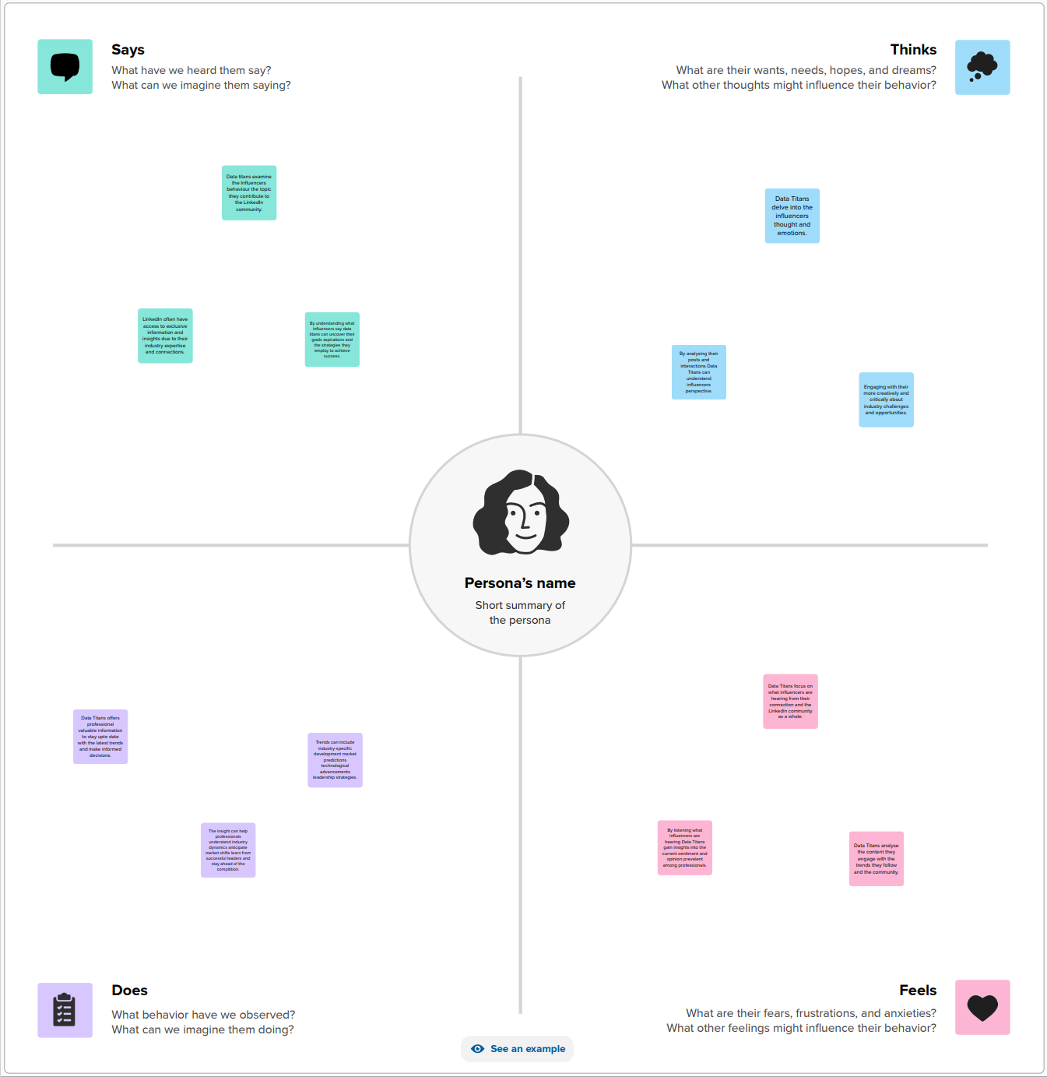

**3.2 Ideation & Brainstorming :**

Brainstorming provides a free and open environment that encourages everyone within a team to participate in the creative thinking process that leads to problem solving. Prioritizing volume over value, out-of-the-box ideas are welcome and built upon, and all participants are encouraged to collaborate, helping each other develop a rich amount of creative solutions.

**Step-1: Team Gathering, Collaboration and Select the Problem Statement :**

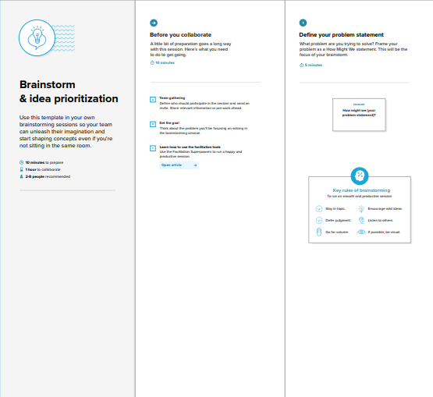

**Step-2: Brainstorm, Idea Listing and Grouping**

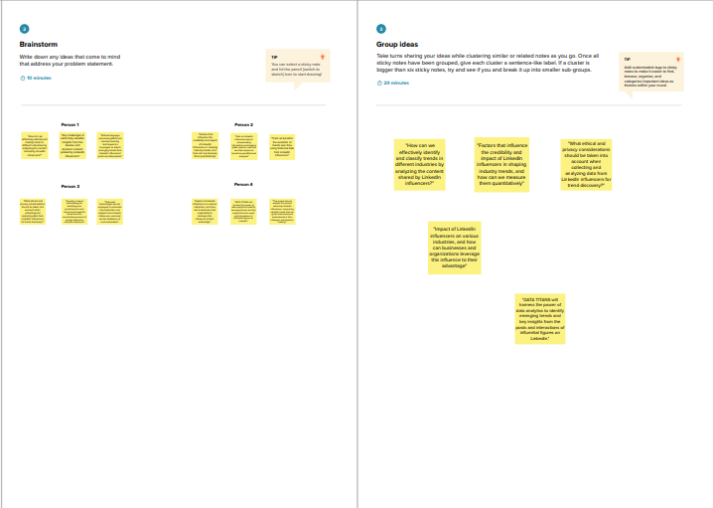

**Step-3: Idea Prioritization**

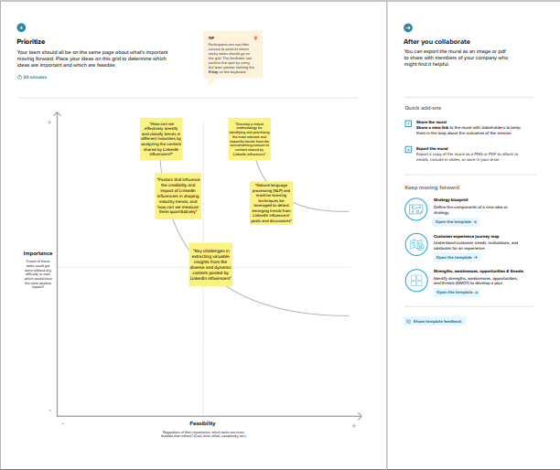

# 4. REQUIREMENT ANALYSIS :

# The requirement analysis for LinkedIn influencers involves assessing their content quality, consistency, engagement levels, and adherence to LinkedIn's policies. It also includes determining the authenticity and accuracy of the information shared, verifying their expertise, and evaluating their influence within their respective industries..

**4.1 Functional requirement :**

* Content Creation
* Audience Engagement
* Industry Knowledge
* Networking
* Authenticity
* Compliance
* Thought Leadership
* Professional Development
* Engagement Metrics
* Collaboration

**4.1 Non-Functional requirement :**

* Performance
* Scalability
* Security
* Availability
* Reliability
* Compliance
* Accessibility
* Responsiveness
* Data Privacy
* Quality of Content

# 5. PROJECT DESIGN :

# The project design for LinkedIn influencers involves conducting a comprehensive analysis of their content, engagement strategies, and impact on professional networking, with the aim of developing actionable insights and recommendations to enhance their influence and contribute to the professional community.

**5. 1 Data Flow Diagrams & User Stories :**

A Data Flow Diagram (DFD) is a traditional visual representation of the information

flows within a system. A neat and clear DFD can depict the right amount of the system requirement graphically. It shows how data enters and leaves the system, what changes the information, and where data is stored.

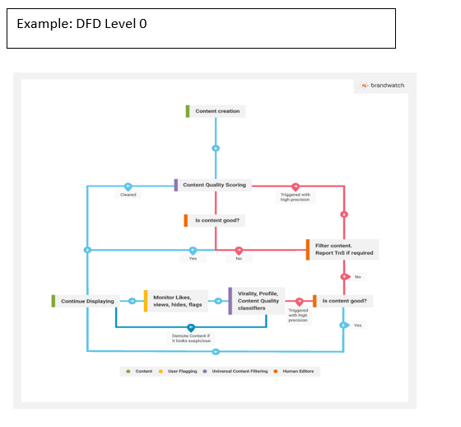

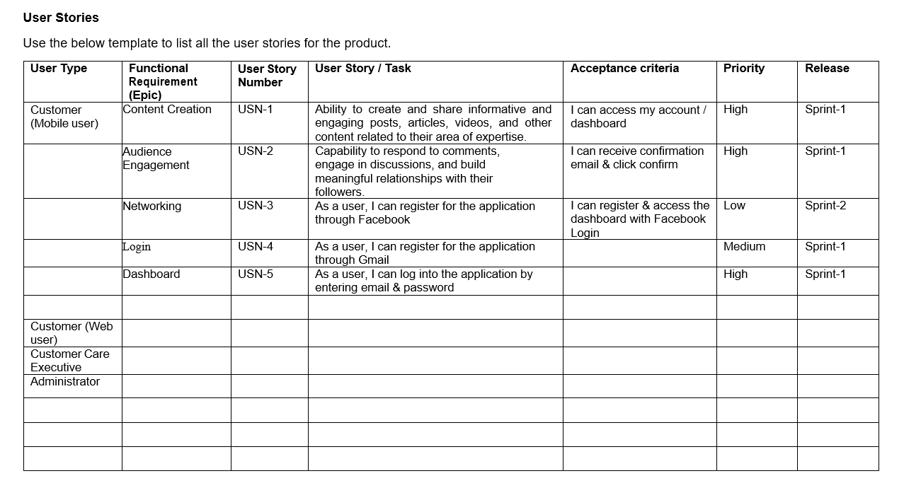

**5.2 Solution Architecture :**

Solution architecture is a complex process – with many sub-processes – that bridges the gap between business problems and technology solutions

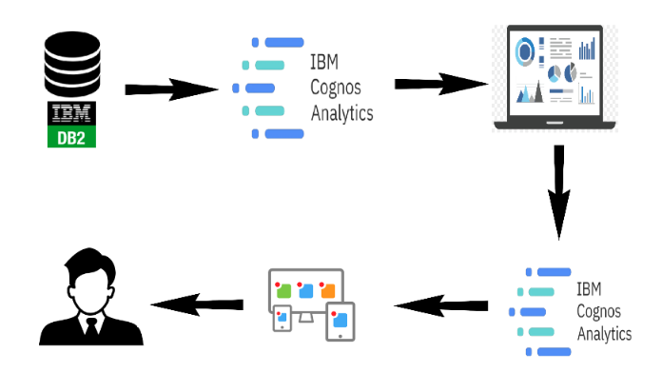

# 6. PROJECT PLANNING & SCHEDULING :

The project planning and scheduling for LinkedIn influencers involves setting specific milestones, allocating time for content creation, engagement activities, and report generation, ensuring a systematic and efficient approach to gather insights and contribute to professional development.

**6.1 Technical Architecture :**

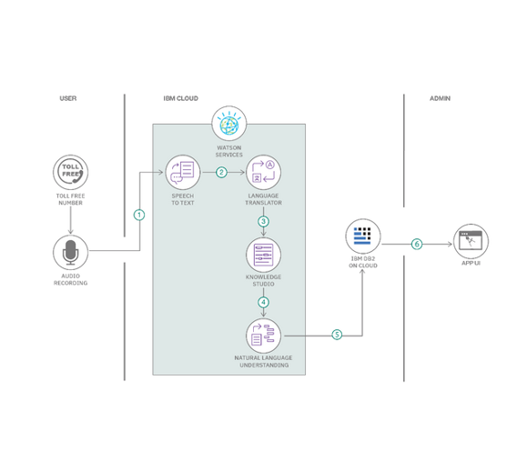

**6.2 Sprint Planning & Estimation :**

Sprint planning and estimation for LinkedIn influencers entails defining achievable content creation and engagement goals, and allocating timeframes to efficiently manage tasks, enabling influencers to stay on track with their networking and content dissemination objectives.

**6.3 Sprint Delivery Schedule :**

The sprint delivery schedule for a LinkedIn influencer outlines the timeline for completing and publishing specific content pieces, ensuring consistent and timely delivery of valuable insights to their followers.

**7. CODING & SOLUTIONING :**

**7. 1 Feature 1: Content Scheduling and Publishing**

This feature allows LinkedIn influencers to plan, schedule, and publish their content at specific times and dates. It enables them to maintain a consistent posting schedule, even during periods when they may not be actively using the platform, ensuring that their insights and expertise reach their followers at optimal times for engagement. This feature also provides flexibility, allowing influencers to plan their content in advance, reducing the need for real-time content creation, and helping them to maintain a strong online presence.

**7. 2 Feature 2: Engagement Analytics Dashboard**

This feature provides LinkedIn influencers with a comprehensive analytics dashboard to track and measure their engagement metrics. It offers insights into the performance of their content, including post reach, likes, comments, shares, and follower demographics. Additionally, it helps influencers identify trends in their engagement data, enabling them to fine-tune their content strategies and better understand their audience's preferences. This tool empowers influencers to make data-driven decisions and optimize their engagement efforts for increased impact and influence.

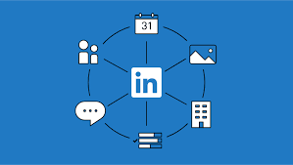

**7.3 Database Schema :**

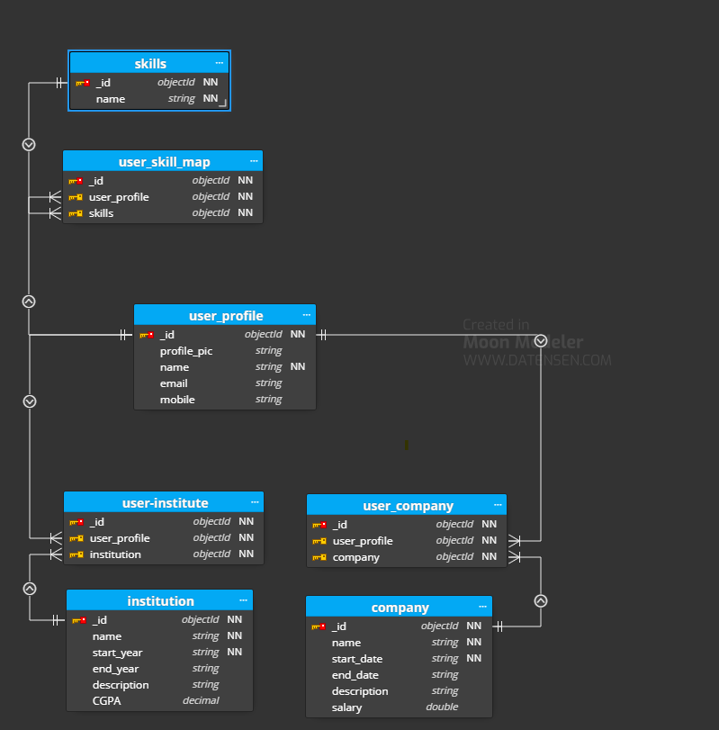

# 8. PERFORMANCE TESTING :

# 8.1 Performance metrics:

# Follower Growth

# Engagement Rate

# Content Reach

# Post Interaction

# Profile Views

# Click-Through Rate (CTR)

# InMail Response Rate

# Profile Endorsements and Recommendations

# Post Virality

# Content Effectiveness

# Influence Score

# Content Consistency

# Network Growth

# Lead Generation

# 9. RESULTS :

**9.1 Output Screenshots :**

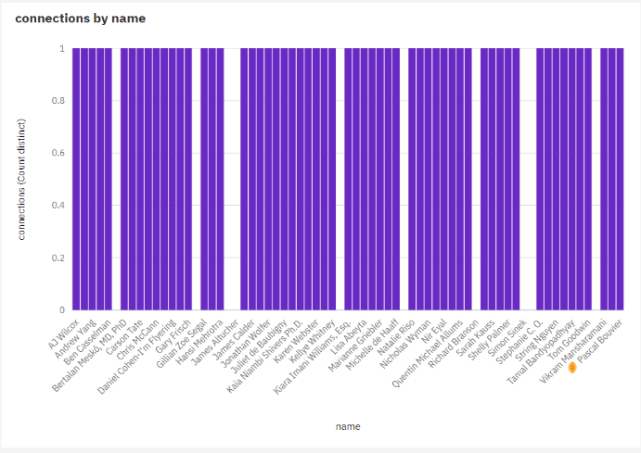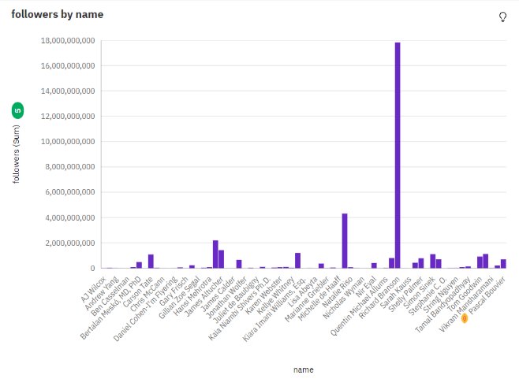

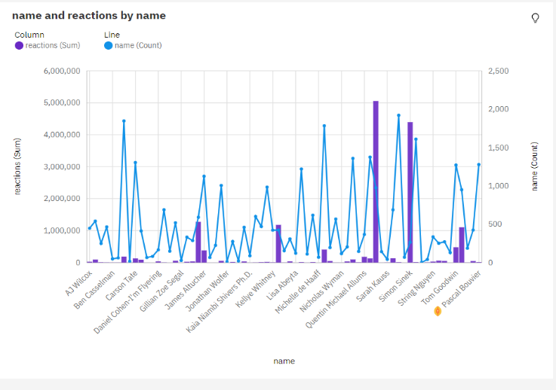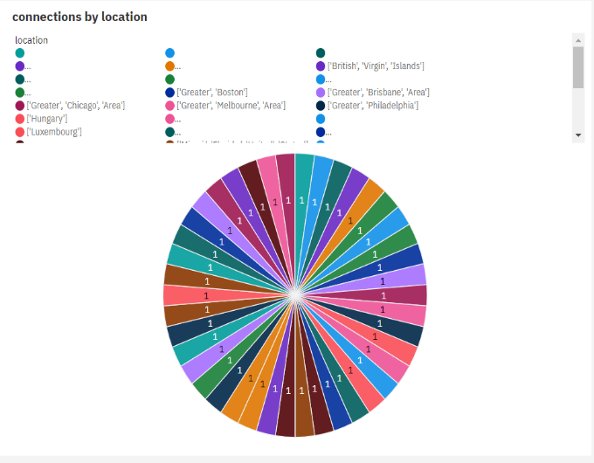

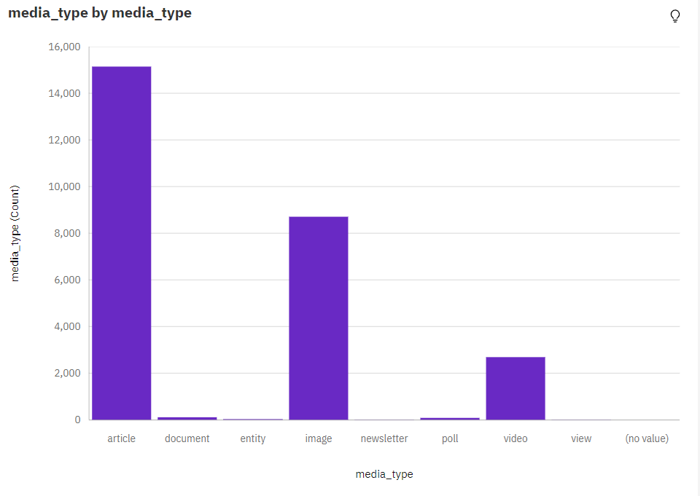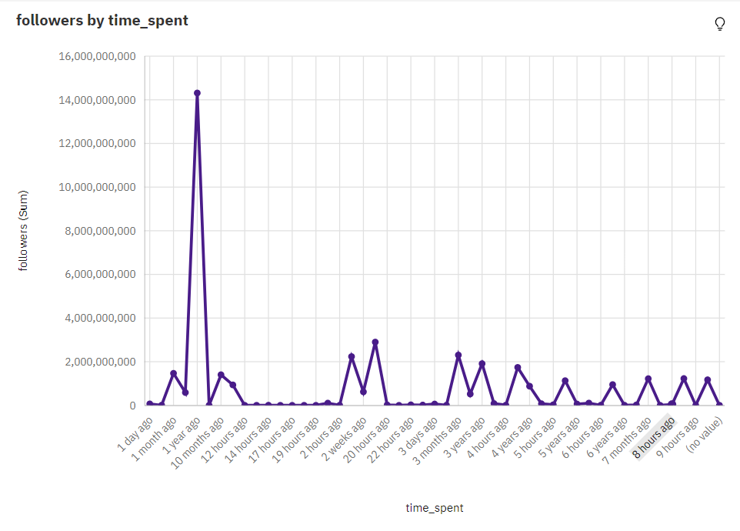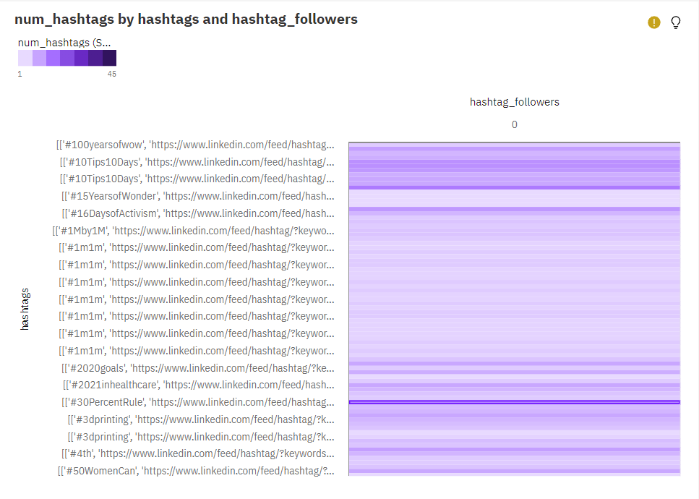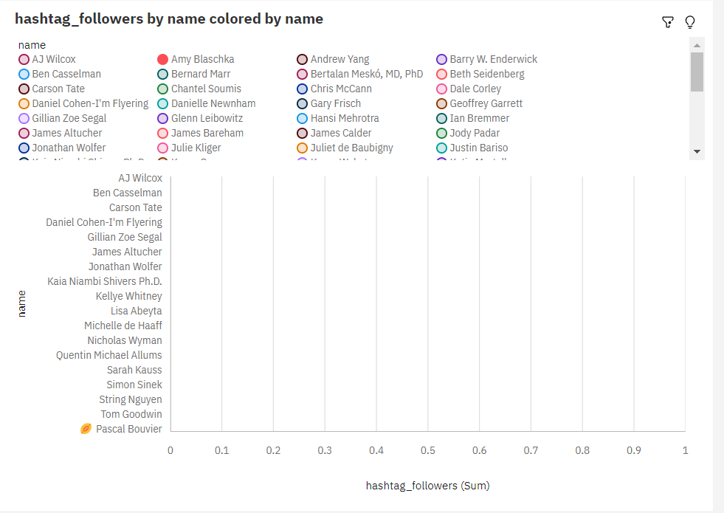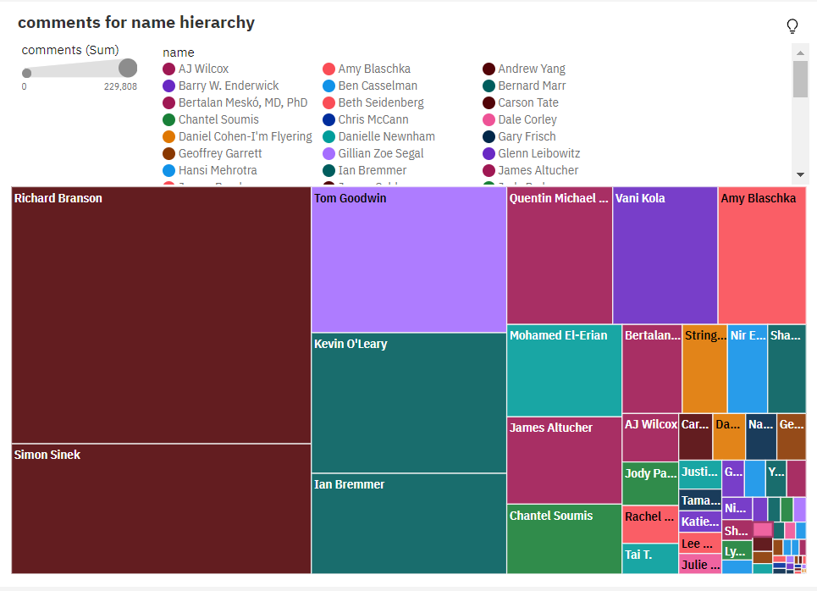

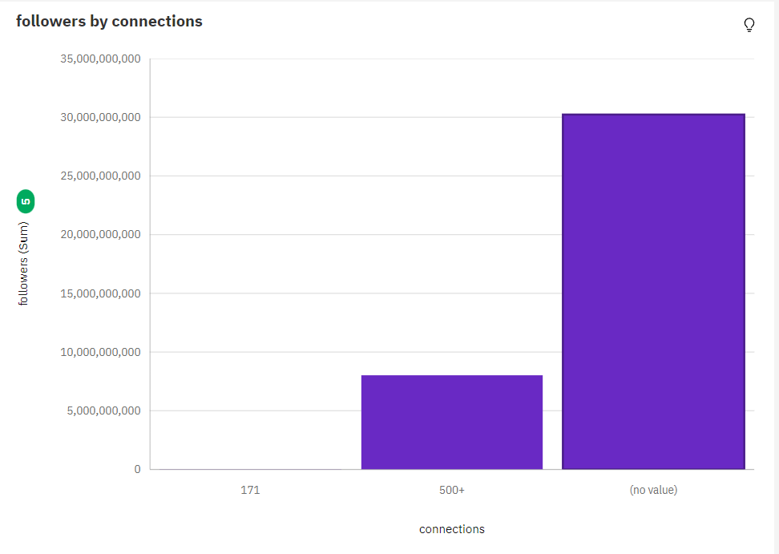

**10. ADVANTAGES & DISADVANTAGES :**

**Advantages :**

* Increased Visibility
* Thought Leadership
* Professional Networking
* Career Opportunities
* Brand Building
* Content Syndication
* Influence Impact
* Mentorship and Guidance
* Community Engagement
* Personal Growth

**Disadvantage :**

* Increased Scrutiny
* Content Overload
* Balancing Privacy
* Content Quality Pressure
* Follower Expectations
* Inauthentic Networking
* Content Plagiarism
* Relevance Maintenance
* Competitive Landscape
* Algorithm ChangesTop of Form

**11. CONCLUSION :**

In conclusion, LinkedIn influencers play a vital role in shaping the professional landscape on the platform. Their expertise, insights, and thought leadership are instrumental in fostering knowledge sharing, networking, and industry discussions. The advantages of being a LinkedIn influencer, such as increased visibility, thought leadership, and career opportunities, are substantial. However, influencers also face challenges, including the pressure to consistently produce high-quality content, deal with scrutiny, and balance their professional and personal lives. Nevertheless, their impact on industry trends and the broader professional community is undeniable. As LinkedIn continues to evolve, influencers will remain at the forefront of change, guiding conversations, and driving innovation. Their commitment to knowledge sharing and community engagement helps create a more informed and interconnected professional world, making LinkedIn a platform of immense value for all its users.

Top of Form

**12. FUTURE SCOPE :**

The future scope for LinkedIn influencers is promising, as the platform continues to evolve and professionals increasingly recognize the value of thought leadership and industry insights. Here are some areas where LinkedIn influencers can expect to have a significant impact in the future.

**13. APPENDIX :**

**Source Code :**

<!DOCTYPE html>

<html lang="en">

<head>

<meta charset="utf-8">

<meta content="width=device-width, initial-scale=1.0" name="viewport">

<title>Linkedin Influncers Analysis </title>

<meta content="" name="description">

<meta content="" name="keywords">

<!-- Favicons -->

<!--<link href="assets/img/favicon.png" rel="icon">

<link href="assets/img/apple-touch-icon.png" rel="apple-touch-icon">-->

<!-- Google Fonts -->

<link href="https://fonts.googleapis.com/css?family=Open+Sans:300,300i,400,400i,600,600i,700,700i|Krub:300,300i,400,400i,500,500i,600,600i,700,700i|Poppins:300,300i,400,400i,500,500i,600,600i,700,700i" rel="stylesheet">

<!-- Vendor CSS Files -->

<link href="assets/vendor/aos/aos.css" rel="stylesheet">

<link href="assets/vendor/bootstrap/css/bootstrap.min.css" rel="stylesheet">

<link href="assets/vendor/bootstrap-icons/bootstrap-icons.css" rel="stylesheet">

<link href="assets/vendor/boxicons/css/boxicons.min.css" rel="stylesheet">

<link href="assets/vendor/glightbox/css/glightbox.min.css" rel="stylesheet">

<link href="assets/vendor/swiper/swiper-bundle.min.css" rel="stylesheet">

<!-- Template Main CSS File -->

<link href="assets/css/style.css" rel="stylesheet">

<!-- =======================================================

* Template Name: Bikin

* Updated: Sep 18 2023 with Bootstrap v5.3.2

* Template URL: https://bootstrapmade.com/bikin-free-simple-landing-page-template/

* Author: BootstrapMade.com

* License: https://bootstrapmade.com/license/

======================================================== -->

</head>

<body>

<!-- ======= Header ======= -->

<header id="header" class="fixed-top">

<div class="container d-flex align-items-center justify-content-between">

<h1 class="logo"><a href="index.html">Linkedin Influncers Analysis</a></h1>

<!-- Uncomment below if you prefer to use an image logo -->

<nav id="navbar" class="navbar">

<ul>

<li><a class="nav-link scrollto active" href="#hero">Home</a></li>

<li><a class="nav-link scrollto" href="#about">About</a></li>

<li><a class="nav-link scrollto" href="#services">Dashboard</a></li>

<li><a class="nav-link scrollto " href="#portfolio">Story</a></li>

<li><a class="nav-link scrollto" href="#team">Report</a></li>

<i class="bi bi-list mobile-nav-toggle"></i>

</nav><!-- .navbar -->

</div>

</header><!-- End Header -->

<!-- ======= Hero Section ======= -->

<section id="hero" class="d-flex align-items-center">

<h1>Linkedin Influncers Analysis</h1>

<h2>Identifying the Linkedin user search</h2>

<a href="#about" class="btn-get-started scrollto">Get Started</a>

</section><!-- End Hero -->

<main id="main">

<!-- ======= About Section ======= -->

<section id="about" class="about">

<div class="container">

<div class="row no-gutters">

<div class="content col-xl-5 d-flex align-items-stretch" data-aos="fade-right">

<div class="content">

<h3>Voluptatem dignissimos provident quasi</h3>

<p>

Lorem ipsum dolor sit amet, consectetur adipiscing elit, sed do eiusmod tempor incididunt ut labore et dolore magna aliqua. Duis aute irure dolor in reprehenderit

</p>

<a href="#" class="about-btn">About us <i class="bx bx-chevron-right"></i></a>

</div>

</div>

<div class="col-xl-7 d-flex align-items-stretch" data-aos="fade-left">

<div class="icon-boxes d-flex flex-column justify-content-center">

<div class="row">

<div class="col-md-6 icon-box" data-aos="fade-up" data-aos-delay="100">

<i class="bx bx-receipt"></i>

<h4>Corporis voluptates sit</h4>

</div>

<div class="col-md-6 icon-box" data-aos="fade-up" data-aos-delay="200">

<i class="bx bx-cube-alt"></i>

<h4>Ullamco laboris nisi</h4>

</div>

<div class="col-md-6 icon-box" data-aos="fade-up" data-aos-delay="300">

<i class="bx bx-images"></i>

<h4>Labore consequatur</h4>

</div>

<div class="col-md-6 icon-box" data-aos="fade-up" data-aos-delay="400">

<i class="bx bx-shield"></i>

<h4>Beatae veritatis</h4>

<p>Expedita veritatis consequuntur nihil tempore laudantium vitae denat pacta</p>

</div>

</div>

</div><!-- End .content-->

</div>

</div>

</div>

</section><!-- End About Section -->

<!-- ======= Clients Section ======= -->

<section id="clients" class="clients">

<div class="container" data-aos="zoom-in">

<div class="row">

<div class="col-lg-2 col-md-4 col-6 d-flex align-items-center justify-content-center">

<img src="assets/img/clients/client-1.png" class="img-fluid" alt="">

</div>

<div class="col-lg-2 col-md-4 col-6 d-flex align-items-center justify-content-center">

<img src="assets/img/clients/client-2.png" class="img-fluid" alt="">

</div>

<div class="col-lg-2 col-md-4 col-6 d-flex align-items-center justify-content-center">

<img src="assets/img/clients/client-3.png" class="img-fluid" alt="">

</div>

<div class="col-lg-2 col-md-4 col-6 d-flex align-items-center justify-content-center">

<img src="assets/img/clients/client-4.png" class="img-fluid" alt="">

</div>

<div class="col-lg-2 col-md-4 col-6 d-flex align-items-center justify-content-center">

<img src="assets/img/clients/client-5.png" class="img-fluid" alt="">

</div>

<div class="col-lg-2 col-md-4 col-6 d-flex align-items-center justify-content-center">

<img src="assets/img/clients/client-6.png" class="img-fluid" alt="">

</div>

</div>

</div>

</section><!-- End Clients Section -->

<!-- ======= Features Section ======= -->

<!--<section id="features" class="features" data-aos="fade-up">

<div class="container">

<div class="section-title">

<h2>Features</h2>

<div class="row content">

<div class="col-md-5" data-aos="fade-right" data-aos-delay="100">

<img src="assets/img/features-1.png" class="img-fluid" alt="">

</div>

<div class="col-md-7 pt-4" data-aos="fade-left" data-aos-delay="100">

<div class="row content">

<div class="col-md-5 order-1 order-md-2" data-aos="fade-left">

<img src="assets/img/features-2.png" class="img-fluid" alt="">

</div>

<div class="col-md-7 pt-5 order-2 order-md-1" data-aos="fade-right">

<h3>Corporis temporibus maiores provident</h3>

</div>

<div class="row content">

<div class="col-md-5" data-aos="fade-right">

<img src="assets/img/features-3.png" class="img-fluid" alt="">

</div>

<div class="col-md-7 pt-5" data-aos="fade-left">

<h3>Sunt consequatur ad ut est nulla consectetur reiciendis animi voluptas</h3>

<p>Cupiditate placeat cupiditate placeat est ipsam culpa. Delectus quia minima quod. Sunt saepe odit aut quia voluptatem hic voluptas dolor doloremque.</p>

<ul>

<li><i class="bi bi-check"></i> Ullamco laboris nisi ut aliquip ex ea commodo consequat.</li>

<li><i class="bi bi-check"></i> Duis aute irure dolor in reprehenderit in voluptate velit.</li>

<li><i class="bi bi-check"></i> Facilis ut et voluptatem aperiam. Autem soluta ad fugiat.</li>

</ul>

</div>

</div>

<div class="row content">

<div class="col-md-5 order-1 order-md-2" data-aos="fade-left">

<img src="assets/img/features-4.png" class="img-fluid" alt="">

</div>

<div class="col-md-7 pt-5 order-2 order-md-1" data-aos="fade-right">

<h3>Quas et necessitatibus eaque impedit ipsum animi consequatur incidunt in</h3>

<p class="fst-italic">

Lorem ipsum dolor sit amet, consectetur adipiscing elit, sed do eiusmod tempor incididunt ut labore et dolore

magna aliqua.

</p>

<p>

Ullamco laboris nisi ut aliquip ex ea commodo consequat. Duis aute irure dolor in reprehenderit in voluptate

velit esse cillum dolore eu fugiat nulla pariatur. Excepteur sint occaecat cupidatat non proident, sunt in

culpa qui officia deserunt mollit anim id est laborum

</p>

</div>

</div>

</div>

</section><!-- End Features Section -->

<!-- ======= Steps Section ======= -->

<!--<section id="steps" class="steps">

<div class="container">

<div class="row no-gutters" data-aos="fade-up">

<div class="col-lg-4 col-md-6 content-item" data-aos="fade-up" data-aos-delay="100">

<span>01</span>

<h4>Lorem Ipsum</h4>

<p>Ulamco laboris nisi ut aliquip ex ea commodo consequat. Et consectetur ducimus vero placeat</p>

</div>

<div class="col-lg-4 col-md-6 content-item" data-aos="fade-up" data-aos-delay="200">

<span>02</span>

<h4>Repellat Nihil</h4>

<p>Dolorem est fugiat occaecati voluptate velit esse. Dicta veritatis dolor quod et vel dire leno para dest</p>

</div>

<div class="col-lg-4 col-md-6 content-item" data-aos="fade-up" data-aos-delay="300">

<span>03</span>

<h4> Ad ad velit qui</h4>

<p>Molestiae officiis omnis illo asperiores. Aut doloribus vitae sunt debitis quo vel nam quis</p>

</div>

<div class="col-lg-4 col-md-6 content-item" data-aos="fade-up" data-aos-delay="100">

<span>04</span>

<h4>Repellendus molestiae</h4>

<p>Inventore quo sint a sint rerum. Distinctio blanditiis deserunt quod soluta quod nam mider lando casa</p>

</div>

<div class="col-lg-4 col-md-6 content-item" data-aos="fade-up" data-aos-delay="200">

<span>05</span>

<h4>Sapiente Magnam</h4>

<p>Vitae dolorem in deleniti ipsum omnis tempore voluptatem. Qui possimus est repellendus est quibusdam</p>

</div>

<div class="col-lg-4 col-md-6 content-item" data-aos="fade-up" data-aos-delay="300">

<span>06</span>

<h4>Facilis Impedit</h4>

<p>Quis eum numquam veniam ea voluptatibus voluptas. Excepturi aut nostrum repudiandae voluptatibus corporis sequi</p>

</div>

</div>

</div>

</section><!-- End Steps Section -->

<!-- ======= Services Section ======= -->

<!-- End Services Section -->

<section id="dashboard" class="portfolio">

<div class="container" data-aos="fade-up">

<div class="section-title">

<h2>Dashboard</h2>

</div>

<iframe src="https://us3.ca.analytics.ibm.com/bi/?perspective=dashboard&amp;pathRef=.my_folders%2FLinkedin_Dashboard&amp;closeWindowOnLastView=true&amp;ui_appbar=false&amp;ui_navbar=false&amp;shareMode=embedded&amp;action=view&amp;mode=dashboard&amp;subView=model0000018b7a35e517_00000002" width="1350" height="900" frameborder="0" gesture="media" allow="encrypted-media" allowfullscreen=""></iframe>

</div>

</section>

<!-- ======= Portfolio Section ======= -->

<section id="stroy" class="portfolio">

<div class="container" data-aos="fade-up">

<div class="section-title">

<h2>Story</h2>

</div>

<iframe src="https://us3.ca.analytics.ibm.com/bi/?perspective=story&amp;pathRef=.my_folders%2FLinkedIn_Story&amp;closeWindowOnLastView=true&amp;ui_appbar=false&amp;ui_navbar=false&amp;shareMode=embedded&amp;action=view&amp;sceneId=model0000018b7a6a1a4c_00000000&amp;sceneTime=0" width="1350" height="900" frameborder="0" gesture="media" allow="encrypted-media" allowfullscreen=""></iframe>

</div>

</section><!-- End Portfolio Section -->

<!-- ======= Testimonials Section ======= -->

<!--<section id="testimonials" class="testimonials section-bg">

<div class="container" data-aos="fade-up">

<div class="section-title">

<h2>Testimonials</h2>

<p>Magnam dolores commodi suscipit. Necessitatibus eius consequatur ex aliquid fuga eum quidem. Sit sint consectetur velit. Quisquam quos quisquam cupiditate. Et nemo qui impedit suscipit alias ea. Quia fugiat sit in iste officiis commodi quidem hic quas.</p>

</div>

<div class="testimonials-slider swiper" data-aos="fade-up" data-aos-delay="100">

<div class="swiper-wrapper">

<div class="swiper-slide">

<div class="testimonial-item">

<p>

<i class="bx bxs-quote-alt-left quote-icon-left"></i>

Proin iaculis purus consequat sem cure digni ssim donec porttitora entum suscipit rhoncus. Accusantium quam, ultricies eget id, aliquam eget nibh et. Maecen aliquam, risus at semper.

<i class="bx bxs-quote-alt-right quote-icon-right"></i>

</p>

<img src="assets/img/testimonials/testimonials-1.jpg" class="testimonial-img" alt="">

<h3>Saul Goodman</h3>

<h4>Ceo &amp; Founder</h4>

</div>

</div><!-- End testimonial item -->

<!--<div class="swiper-slide">

<div class="testimonial-item">

<p>

<i class="bx bxs-quote-alt-left quote-icon-left"></i>

Export tempor illum tamen malis malis eram quae irure esse labore quem cillum quid cillum eram malis quorum velit fore eram velit sunt aliqua noster fugiat irure amet legam anim culpa.

<i class="bx bxs-quote-alt-right quote-icon-right"></i>

</p>

<img src="assets/img/testimonials/testimonials-2.jpg" class="testimonial-img" alt="">

<h3>Sara Wilsson</h3>

<h4>Designer</h4>

</div>

</div><!-- End testimonial item -->

<!--<div class="swiper-slide">

<div class="testimonial-item">

<p>

<i class="bx bxs-quote-alt-left quote-icon-left"></i>

Enim nisi quem export duis labore cillum quae magna enim sint quorum nulla quem veniam duis minim tempor labore quem eram duis noster aute amet eram fore quis sint minim.

<i class="bx bxs-quote-alt-right quote-icon-right"></i>

</p>

<img src="assets/img/testimonials/testimonials-3.jpg" class="testimonial-img" alt="">

<h3>Jena Karlis</h3>

<h4>Store Owner</h4>

</div>

</div><!-- End testimonial item -->

<!--<div class="swiper-slide">

<div class="testimonial-item">

<p>

<i class="bx bxs-quote-alt-left quote-icon-left"></i>

Fugiat enim eram quae cillum dolore dolor amet nulla culpa multos export minim fugiat minim velit minim dolor enim duis veniam ipsum anim magna sunt elit fore quem dolore labore illum veniam.

<i class="bx bxs-quote-alt-right quote-icon-right"></i>

</p>

<img src="assets/img/testimonials/testimonials-4.jpg" class="testimonial-img" alt="">

<h3>Matt Brandon</h3>

<h4>Freelancer</h4>

</div>

</div><!-- End testimonial item -->

<!--<div class="swiper-slide">

<div class="testimonial-item">

<p>

<i class="bx bxs-quote-alt-left quote-icon-left"></i>

Quis quorum aliqua sint quem legam fore sunt eram irure aliqua veniam tempor noster veniam enim culpa labore duis sunt culpa nulla illum cillum fugiat legam esse veniam culpa fore nisi cillum quid.

<i class="bx bxs-quote-alt-right quote-icon-right"></i>

</p>

<img src="assets/img/testimonials/testimonials-5.jpg" class="testimonial-img" alt="">

<h3>John Larson</h3>

<h4>Entrepreneur</h4>

</div>

</div><!-- End testimonial item -->

<!--</div>

<div class="swiper-pagination"></div>

</div>

</div>

</section>--><!-- End Testimonials Section -->

<!-- ======= Team Section ======= -->

<section id="Report" class="team">

<div class="container" data-aos="fade-up">

<div class="section-title">

<h2>Report</h2>

</div>

<iframe src="https://us3.ca.analytics.ibm.com/bi/?pathRef=.my_folders%2FLinkedIn_Report&amp;closeWindowOnLastView=true&amp;ui_appbar=false&amp;ui_navbar=false&amp;shareMode=embedded&amp;action=run&amp;format=HTML&amp;prompt=false" width="1350" height="900" frameborder="0" gesture="media" allow="encrypted-media" allowfullscreen=""></iframe>

</div>

</section><!-- End Team Section -->

<!-- ======= Pricing Section ======= -->

<!--<section id="pricing" class="pricing section-bg">

<div class="container" data-aos="fade-up">

<div class="section-title">

<h2>Pricing</h2>

<div class="row">

<div class="col-lg-4 col-md-6" data-aos="zoom-in" data-aos-delay="200">

<div class="box">

<h3>Free</h3>

<h4><sup>$</sup>0<span> / month</span></h4>

<ul>

<li>Aida dere</li>

<li>Nec feugiat nisl</li>

<li>Nulla at volutpat dola</li>

<li class="na">Pharetra massa</li>

<li class="na">Massa ultricies mi</li>

</ul>

<div class="btn-wrap">

<a href="#" class="btn-buy">Buy Now</a>

</div>

</div>

</div>

<div class="box featured">

<h3>Business</h3>

<h4><sup>$</sup>19<span> / month</span></h4>

<ul>

<li>Aida dere</li>

<li>Nec feugiat nisl</li>

<li>Nulla at volutpat dola</li>

<li>Pharetra massa</li>

<li class="na">Massa ultricies mi</li>

</ul>

<div class="btn-wrap">

<a href="#" class="btn-buy">Buy Now</a>

</div>

</div>

</div>

<div class="box">

<h3>Developer</h3>

<h4><sup>$</sup>29<span> / month</span></h4>

<ul>

<li>Aida dere</li>

<li>Nec feugiat nisl</li>

<li>Nulla at volutpat dola</li>

<li>Pharetra massa</li>

<li>Massa ultricies mi</li>

</ul>

<div class="btn-wrap">

<a href="#" class="btn-buy">Buy Now</a>

</div>

</div>

</div>

<!-- ======= Contact Section ======= -->

<!--<section id="contact" class="contact section-bg">

<div class="container" data-aos="fade-up">

<div class="section-title">

<h2>Contact</h2>

</div>

<div class="row">

<div class="col-lg-6">

<div class="row">

<div class="col-md-12">

<div class="info-box">

<i class="bx bx-map"></i>

<h3>Our Address</h3>

<p>A108 Adam Street, New York, NY 535022</p>

</div>

</div>

<div class="col-md-6">

<!-- Vendor JS Files -->

<script src="assets/vendor/aos/aos.js"></script>

<script src="assets/vendor/bootstrap/js/bootstrap.bundle.min.js"></script>

<script src="assets/vendor/glightbox/js/glightbox.min.js"></script>

<script src="assets/vendor/isotope-layout/isotope.pkgd.min.js"></script>

<script src="assets/vendor/swiper/swiper-bundle.min.js"></script>

<script src="assets/vendor/php-email-form/validate.js"></script>

<!-- Template Main JS File -->

<script src="assets/js/main.js"></script>

</body>

</html>

**GitHub & Project Demo Link :**

[**https://www.kapwing.com/videos/6545c8472ebc3a33ccddae6f**](https://www.kapwing.com/videos/6545c8472ebc3a33ccddae6f)

[**https://linkedin-influencer.netlify.app/**](https://linkedin-influencer.netlify.app/)

[**https://github.com/sreesoundariya/NM-153FEE77E2BD77F95DB47FD6C0047366**](https://github.com/sreesoundariya/NM-153FEE77E2BD77F95DB47FD6C0047366)